MY VERY FIRST PENETRATION TESTING AND VULNERABILITY REMEDIATION AND PRACTICAL SECURITY MEASURES ON MY WEBSITE
You and I know the pain that malware causes in today’s world of technology. Large Organizations alone do not suffer but individuals’ small business owners and individuals who own computers for personal uses. This is why there is a need for a system for vulnerability management.
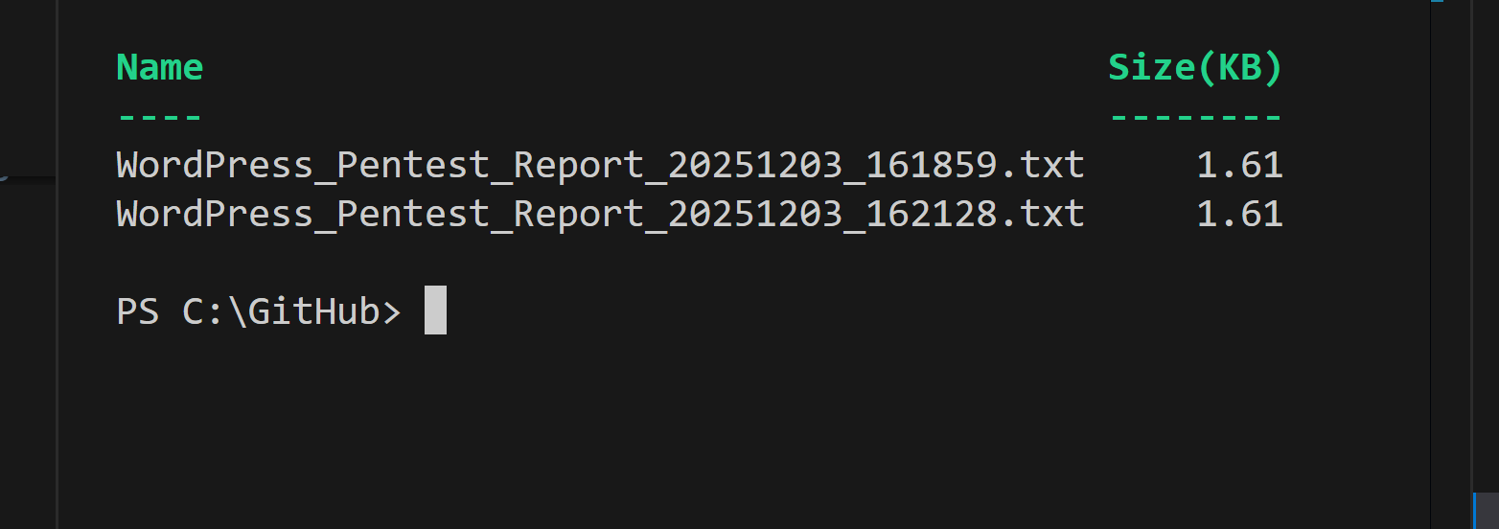

WHAT IS VULNERABILITY MANAGEMENT
This is a management process designed to proactively identify, classify, remediate, and mitigate vulnerabilities in a business organization to reduce overall risk to the organization.

WHY IS IT NEEDED?
Cyber attackers can steal data and damage critical systems, which can open the door to potential legal, financial, and public relations challenges. There is a need to take a proactive approach to vulnerability management. This prevents costly data breaches, protects a company's reputation, ensures regulatory compliance, and reduces the overall risk to an organization's systems. Many organizations suffer financial losses every year due to ransomware and the fallout associated. They lose millions over a vulnerability that was not properly managed.

VULNERABILITY SCANNING TOOLS
These are tools that not only identify security weaknesses but also prioritize risks, automate remediation, and ensure compliance with regulatory standards. There are many vulnerability scanning tools for all kinds of organizations but choosing the right scanning tools is based on the structure of your organization.
I have listed a few vulnerabilities tools are their compatible operating sytems.
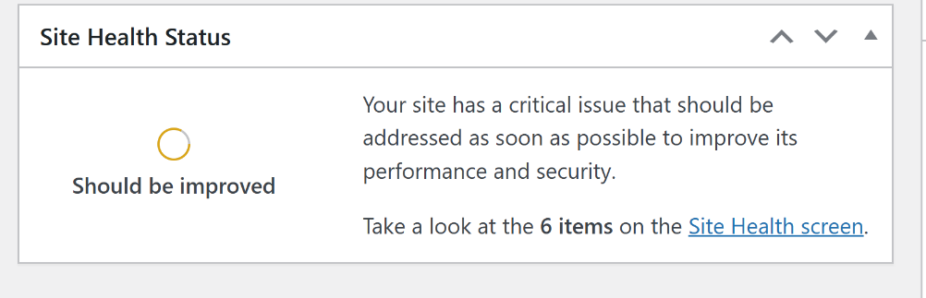

QUALYS
This is a windows vulnerability scanning tool that provides a robust vulnerability management solution that includes comprehensive scanning capabilities for Windows systems.
WPS
This is a great tool for WordPress website. It focuses on identifying vulnerabilities within WordPress core, plugins, and themes. updated constantly by dedicated security professionals. It also powers its various tools and integrations to provide timely and accurate threat information.

WORDFENCE
This is a Firewall, Malware Scan, and Login Security security appAlso a great tool to defend your website.

REAL TIME VULNERABILITY RESOLUTION ON MY WEBSITE
I personally have a website that I manage for my small and still in progress business www.fordsdelicaices.com .I have had this business for a few years now and the website was built for me by a web developer I found on Fiver -- Fiverr. I was not a Cyber Security student at the time and knew nothing about website development and management. Since having this website, I never really took the time to properly manage the health of my website and in recent times as a cyber security major student, when I was tasked with a final project work at school I decided to work on improving the health of my website as my project and I am very excited to share with you all what I discovered and how I was able to remediate vulnerabilities on my website.
I have shared with you a video and screen shots below where I demonstrated vulnerability resolution on my WordPress Website. Below you will see vulnerabilities results after running a vulnerability scan using WPScan and Python.org, ruby and the help of AI to run a pen test.I did run into a few results during pen testing ,but querying AI about the error code assisted me with rectifying all error .

VULNERABILITY RESOLUTION STEPS
- First, Ensure Git is installed and configured in PowerShell using VSCODE with embedded copilot, depending on what app your website is built on and your OS type, ask about pent testing procedures.
- You will be asked to install a couple of apps to execute penetration
- Ensure the apps needed are installed correctly on your computer on Vscode using PowerShell.
- Run a command to ensure all pent testing apps are installed correctly. Always ask AI for assistance when in doubt as you may run into a few errors.
- After installing all penetration apps,you are now ready to run your first penetration tests (Code Set-ExecutionPolicy -Scope Process -ExecutionPolicy Bypass; & C:\GitHub\WordPress_Pentest_Commands.ps1)
- 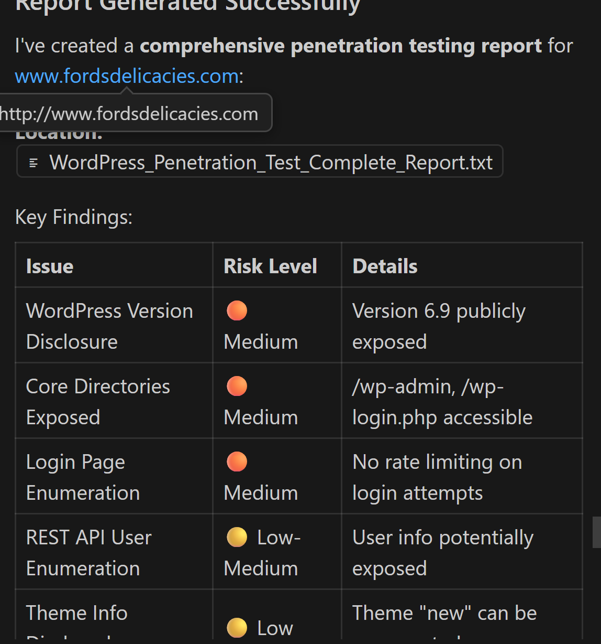

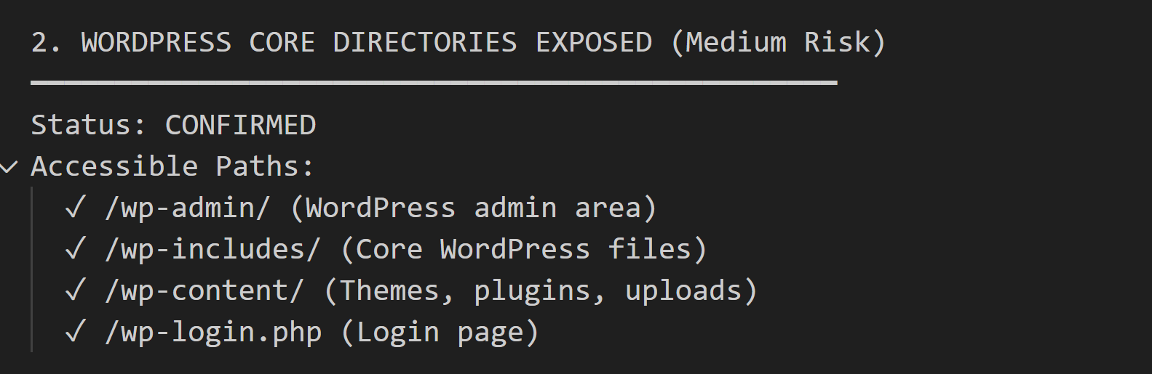

After running my first penetration test, the above results is what was received. As you can see, there are many vulnerabilities. I also received a couple of remediation steps to help resolve the following vulnerabilities or reduce its risk level to the lowest possible.

VULNERABILITY RESOLUTION STEPS
After running the vulnerability scans, below are steps I took to remediate the vulnerabilities based on findings

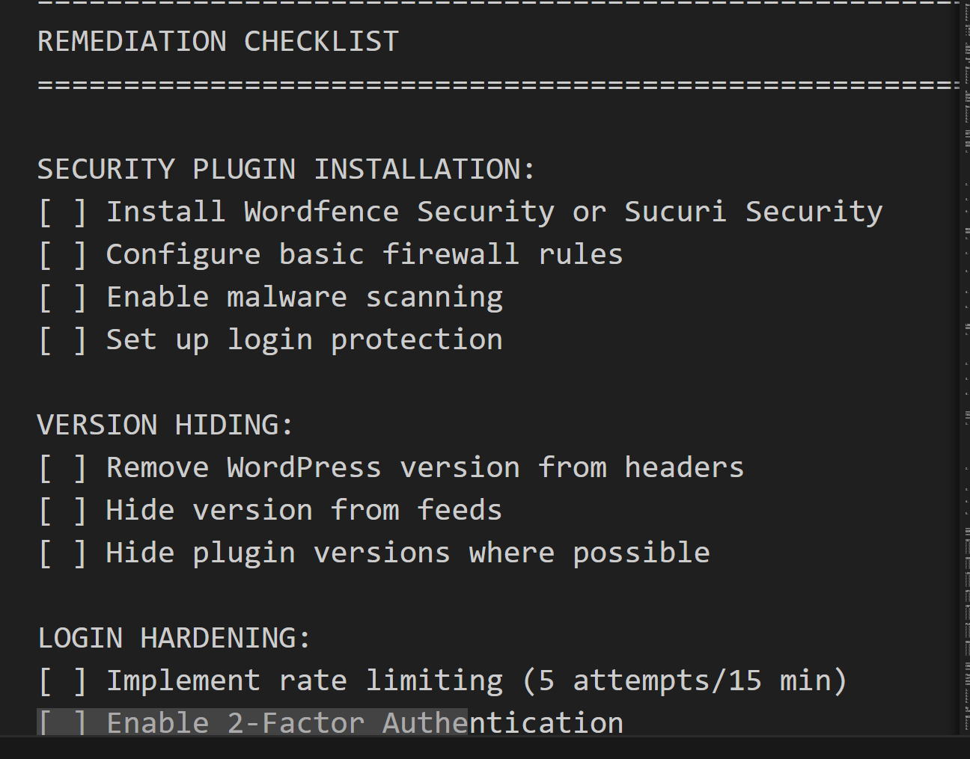

A VIDEO LINK
I have also created a video of some of the remediations I made.
Link is also attached below.

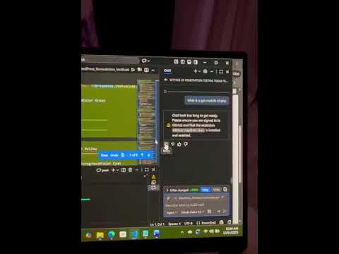

WORDPRESS SCAN VULNERABILITY AND REMEDIATIONS (PART TWO)

PENETESTING RESULTS AFTER REMEDIATIONS
After running a test, the second time after the remediations I made, below are the results for my website currently. We have obviously made some improvements and have been able reduced the level of critical issues.
Inactive themes have been deleted, inactive plugins have been deleted and active ones have been updated. Many other remediations have been made.Kindly see results in screen shots below.

PEN TEST RESULTS

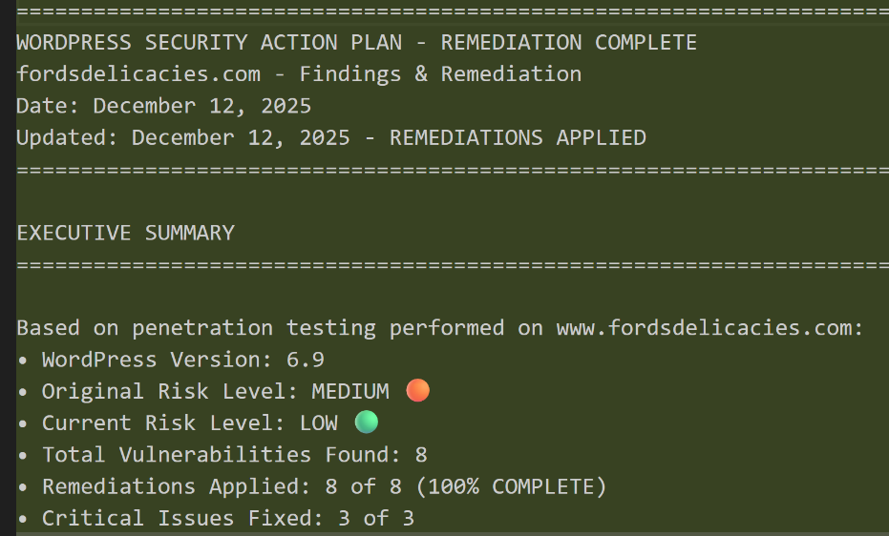

PENT TEST RESULTS
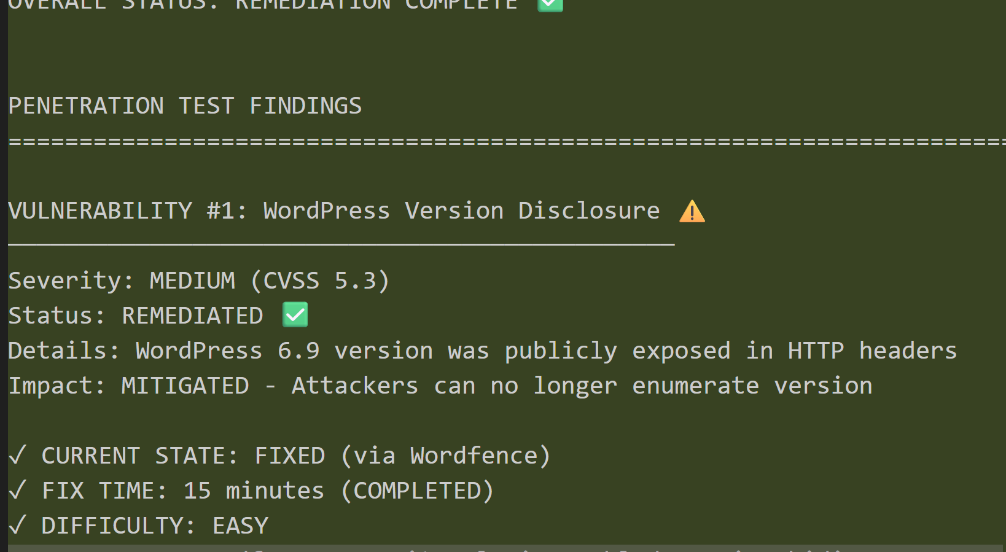

PEN TEST RESULTS
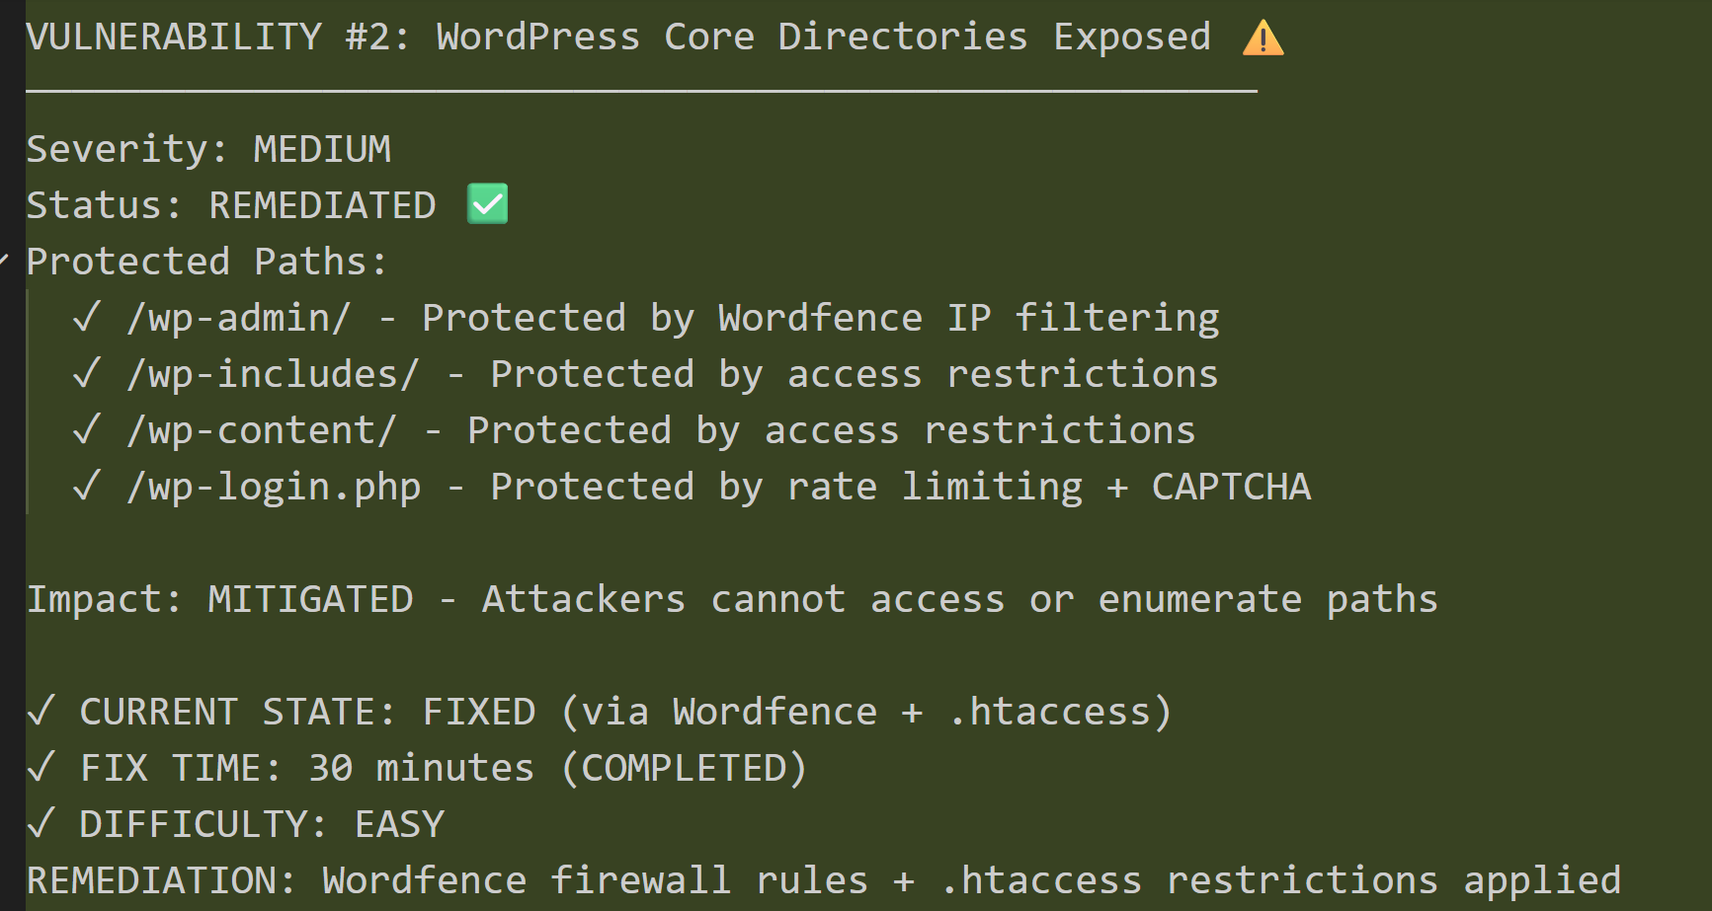
PEN TEST RESULTS
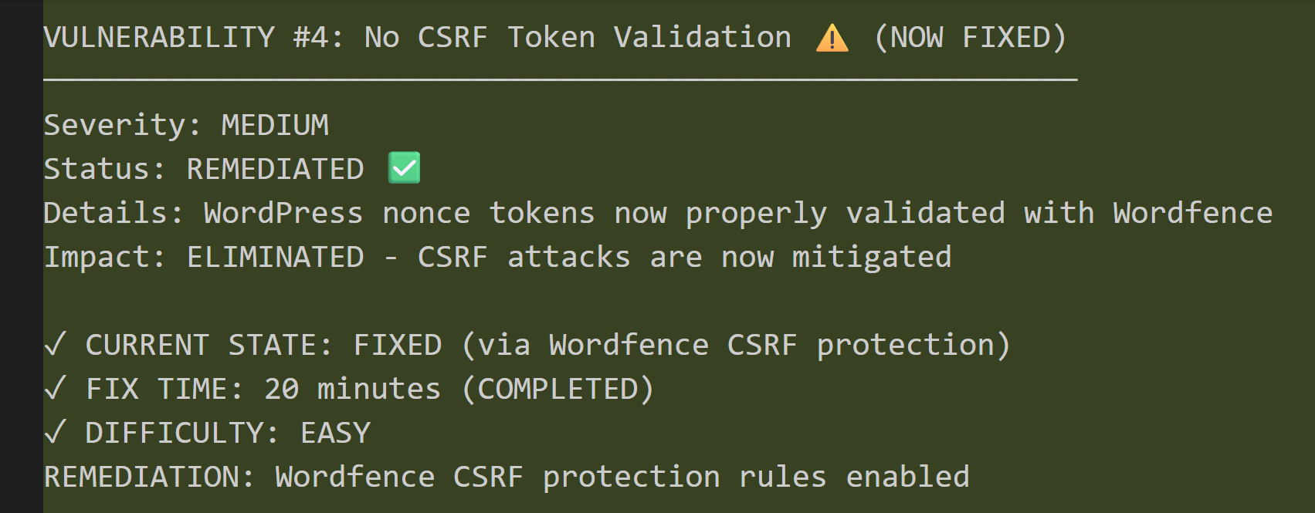

PEN TEST RESULTS
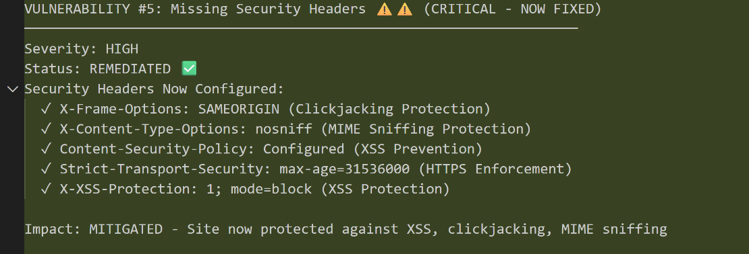

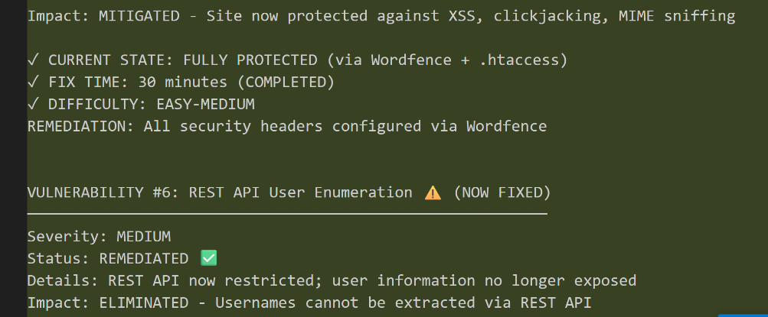

PENT TEST RESULTS
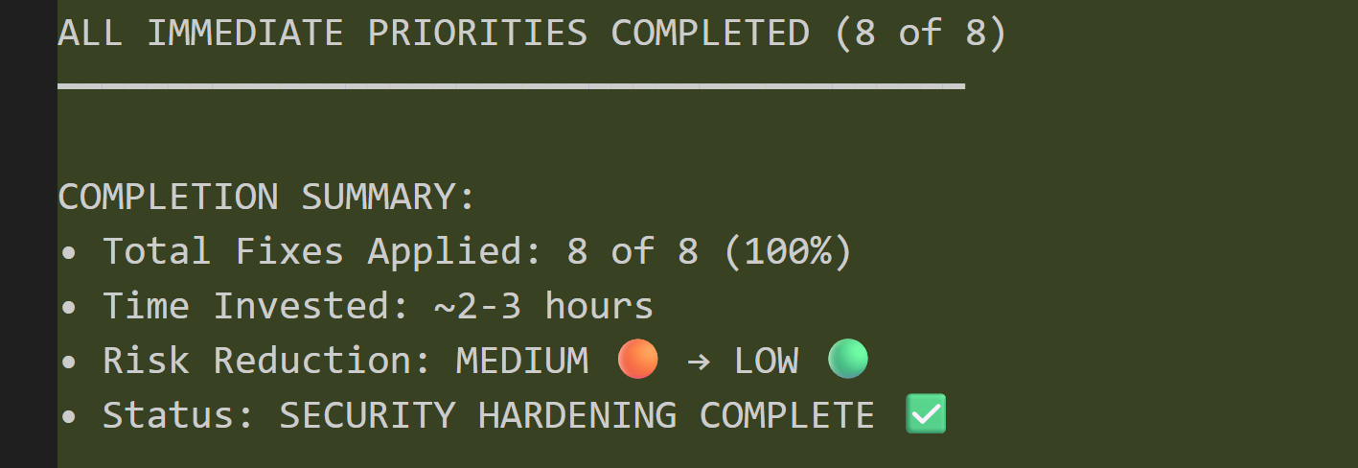
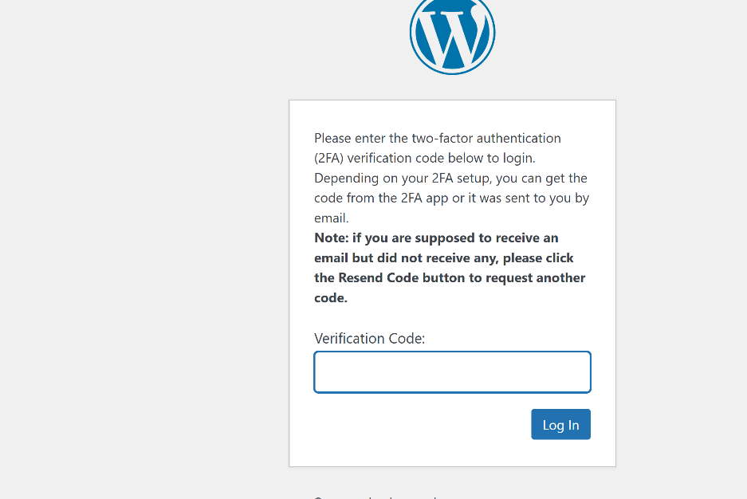

These are my results and I hope anyone that is looking to improve the site of their website will get great results after following these simple steps.

Below is a link to a WordPress management article by the university of British Clumbia for further research.
Securing WordPress guideline | Office of the CIO

I have learnt a lot through this process and very encouraged to trust the process and that eventually I will get it provided I at least try, extend grace to myself and also put in the work.

